**Minikube with Namespace**

Task : Setup minikube at your local and explore creating namespaces (Go through official documentation)

Minikube installation in ec2 instance

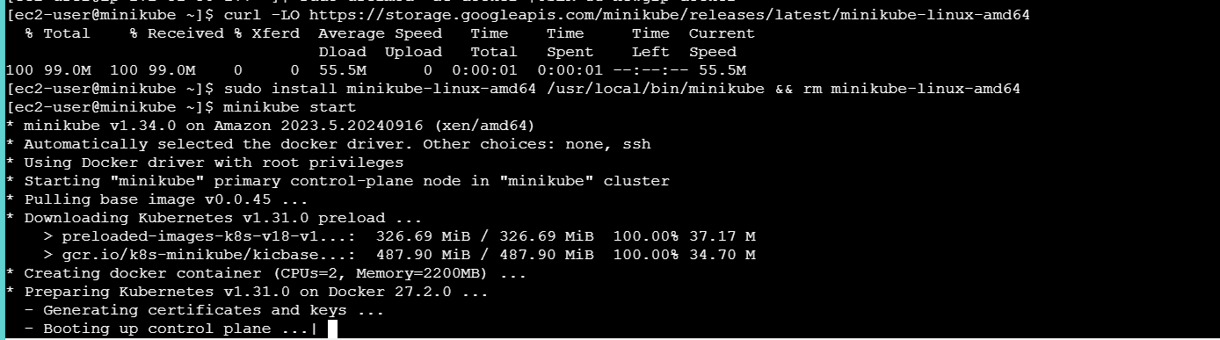

Install kubectl

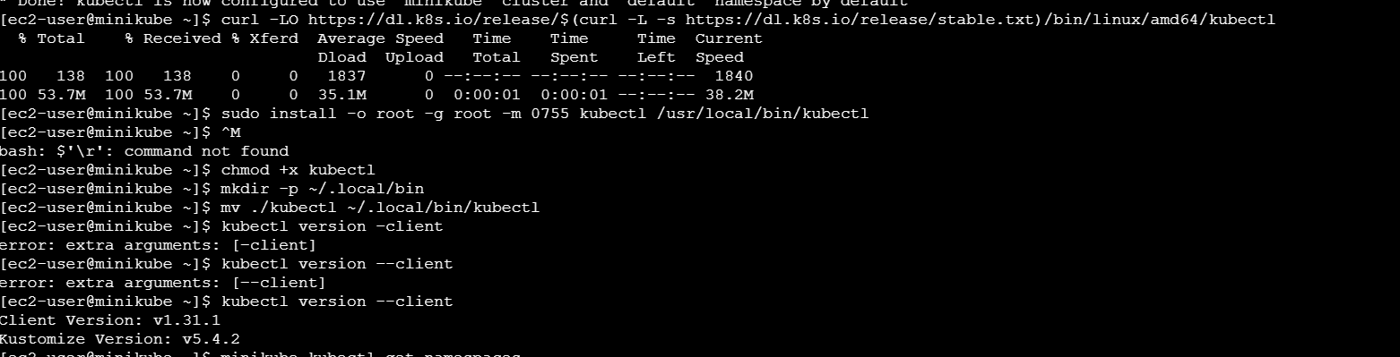

**Namespace**

1. List namespaces

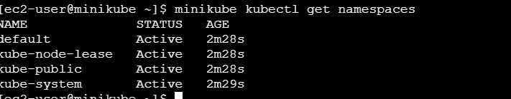

1. Create a namespace

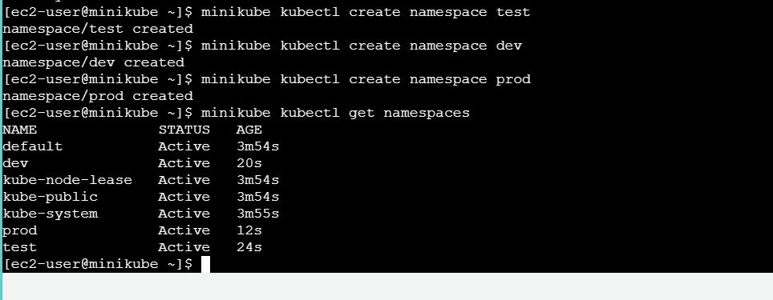

In above screenshot created 3 namespace

1. Delete a namespace

Deleted dev namespace

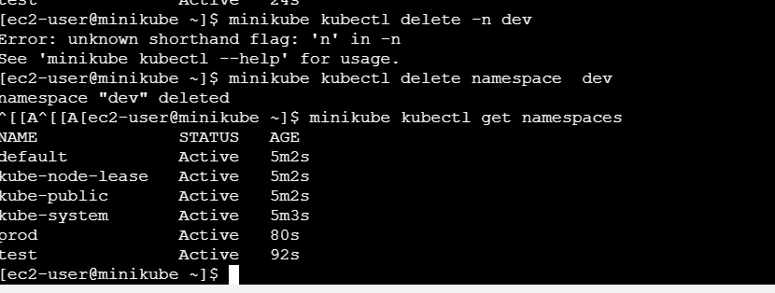

1. Describe a namespace

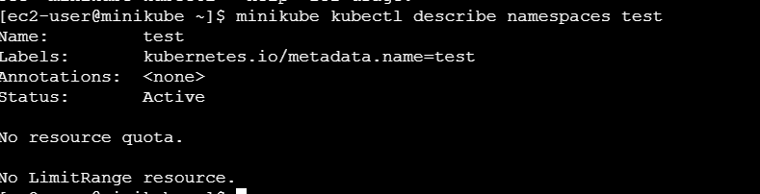

1. Set the Default Namespace for kubectl

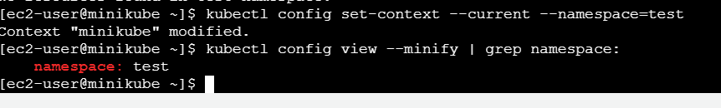

1. Label a namespace and list the namespace with labels

